Statewide Water Planning: The Georgia Experience
Jeffrey D. Mullen
Footnote: Jeffrey D. Mullen is an associate professor, Department of Agricultural and Applied Economics, University of Georgia, Athens, Georgia.
Running Head: Statewide Water Planning
Several states in the southeast have acknowledged the need for statewide water planning but have yet to act. In contrast, Georgia is on the cusp of completing the Georgia Comprehensive Statewide Water Management Plan (SWMP). The SWMP provides for resource assessments, forecasts, and regional water planning. Over the past three years, an extensive effort has been made to implement the SWMP. This paper describes the planning process undertaken in Georgia. Several of the recommended practices are also highlighted and critiqued with respect to their potential to affect aggregate water use in the state.
Keywords: residential water use, water management, water planning, irrigation
JEL Classifications: Q25, Q28, R58
A quick look at an annual precipitation map of the United States (see Figure 1) illustrates a clear east-west dichotomy. States east of Oklahoma enjoy precipitation levels well above 30 inches per year, with a particularly wet pocket in the southeast. This spatial distribution of precipitation also serves as a reasonable guide to water rights regimes throughout the US. The “dry” western states, facing water scarcity since their inception, have generally embraced prior appropriations as the foundational principal for allocating water. Often, volumetric allotments are clearly ascribed to users and those rights are typically prioritized on a first-in-time, first-in-right basis. In contrast, the “wet” eastern states have generally instituted variants of the riparian doctrine, calling for “reasonable uses” of water that do not impinge upon the ability of others to also reasonably use water. The underlying sentiment seems to be that the water is there for us to share. Of course, sharing is easy when resources are abundant.
While the eastern states have not been immune to periodic drought, over the past several decades increasing populations and changes in agricultural production, particularly in the southeast, have jointly raised the specter of water scarcity as the new status quo. In an effort to address future water scarcity issues, several states have articulated the need for state-wide water planning. Budgets constraints, however, have prevented many from dedicating the resources necessary for such an endeavor. An exception is the state of Georgia, which is scheduled to complete the Statewide Comprehensive Water Management Plan by the end of 2011. Eventually, when other states in the region embark on their own initiatives, they may learn from the approach Georgia has taken to planning for future water quantity and quality challenges. With that in mind, the objective of this paper is to highlight key aspects of Georgia’s state-wide water planning process. Additional details for much of the information presented here is available online at www.georgiawaterplanning.org.
Background
As mentioned earlier, the southeastern United States, including the state of Georgia, has weathered numerous, multi-year droughts over the last 120 years. This can be seen across a number of indices including the Standardized Precipitation Index (SPI), Palmer Z Index, Palmer Drought Severity Index (PDSI), and Palmer Hydrological Drought Index (PHDI). Over the past 40 years, however, the impact of these supply shortfalls has been exacerbated by considerable increases in water demand. Figure 2, using population and irrigated acres as proxies for potential water demand, illustrates how conditions have changed over the past century.
The effects of population growth and agricultural production on water resources are not restricted to drought years in Georgia. The rapid increase in population around the Atlanta metropolitan area since 1980 has also led to prolonged legal battles with two of Georgia’s neighbors, Alabama and Florida. One point of contention is the flow of the Chattahoochee River, which runs nearly half the length of the Georgia-Alabama border. At its confluence with the Flint River the Apalachicola River is born and travels through the Florida panhandle to the Gulf of Mexico.
In the late 1980s, the U.S. Army Corps of Engineers formally recommended part of Lake Lanier, a reservoir on the Chattahoochee River north of Atlanta, be allocated for use by metropolitan Atlanta. This prompted Alabama to contest the legality of the allocation – the lake had never been designated for water supply, but rather for hydropower generation. Florida’s concerns for flows in the Apalachicola River, which are related to flows in the Chattahoochee and Flint rivers, led to further legal trouble for Georgia. The legal uncertainty of the state’s water supply – which continues to date – coupled with water demand pressures and a drought led the Association of County Commissioners of Georgia to call for a comprehensive water plan for the state in 1999. By 2004, Georgia’s General Assembly passed the Comprehensive Statewide Water Management Planning Act, hereafter referred to as “the Act”.
The Act set forward a number of guiding principles and established a water council to coordinate the planning process. The water council was comprised of 2 political appointees (one appointed by the speaker of the house and one appointed by the president pro tempore of the senate), the chairpersons of the Georgia House and Senate Natural Resource and Environment Committees, the director of the Environmental Protection Division (EPD) of the Department of Natural Resources, and several other governmental officials. The guiding principles acknowledged the importance of water resources to all of Georgia’s citizens, including future generations, the connection between economic prosperity and environmental quality, and the need for periodic revision of a plan. The specific principles include:
- Effective water resources management protects public health and the safety and welfare of Georgia´s citizens;
- Water resources are to be managed in a sustainable manner so that current and future generations have access to adequate supplies of quality water that support both human needs and natural systems;
- All citizens have a stewardship responsibility to conserve and protect the water resources of Georgia;
- Water resources management efforts must have a sound scientific foundation and recognize that economic prosperity and environmental quality are interdependent;
- Water quality and quantity and surface and ground water are interrelated and require integrated planning as well as reasonable and efficient use;
- A comprehensive and accessible data base must be developed to provide sound scientific and economic information upon which effective water resources management decisions can be based;
- Water resources management encourages local and regional innovation, implementation, adaptability, and responsibility for watershed and river basin management;
- Sound water resources management involves meaningful participation, coordination, and cooperation among interested and affected stakeholders and citizens as well as all levels of governmental and other entities managing or utilizing water; and
- Periodic revisions of the comprehensive state-wide water management plan may be required to accommodate new scientific and policy insights as well as changing social, economic, cultural, and environmental factors.
In January of 2008, the General Assembly adopted the Comprehensive Statewide Water Management Plan (CSWMP). The plan is, in effect, a plan for more planning. As the Executive Summary of the CSWMP states, “the comprehensive state plan hinges on development of regional water plans. Regional forecasts of future needs for water and wastewater will be completed. Then, regional plans will be developed to identify the management practices to be employed, following state policy and guidance, to ensure that the anticipated demands can be met.” The CSWMP also provides for resource assessments.
Figure 3 presents a schematic, developed by EPD, of the implementation schedule. Over the past three years, an extensive effort has been made to realize the schedule. Decadal forecasts up to the year 2050 were completed for the agriculture, domestic, commercial, industrial, and energy sectors and, to complement the demand forecasts, assessments of groundwater and surface water availability were made. In addition, the assimilative capacity of each of Georgia’s fourteen major river basins has been assessed. Eleven regional water planning councils have also been established and are currently identifying water management practices to address projected gaps between forecasted water demand and available water resources.
Regional Water Planning Councils
There are fourteen major river basins and several major aquifers in the state of Georgia. The regional water planning councils established by the CSWMP are, ultimately, demarcated by county boundaries, but the counties are congregated into councils based on hydrologic boundaries.
The councils are comprised of no more than 25 appointed members, ideally representing the full spectrum of stakeholders. Nominations were solicited from stakeholder groups and organizations, although the nomination process was open to all. The nominations were then vetted through the EPD, Department of Agriculture, Department of Community Affairs, and the Department of Economic Development, and subsequently forwarded to the governor, lieutenant governor, and the speaker of the house. The governor appointed 13 members to each council, while the lieutenant governor and speaker each appointed 6 members.
Council members are required to reside in the region. Additionally, of the 13 members appointed by the governor, 2 are required to be mayors or city council members within the region, and 2 are required to be county-level elected officials. Similarly, the lieutenant governor and speaker must each appoint at least one mayor or city council member and one county-level elected official.
The EPD provides guidance and training to the council members, but each council is given considerable autonomy with respect to establishment of operating procedures. This includes procedures for council decision-making. Each council is also granted the authority to establish provisions for advisory boards and public participation. The only stipulation is that the public have “meaningful” opportunities for participation. Ultimately, however, council procedures are formally adopted through a memorandum of agreement (MOA) with EPD and the Department of Community Affairs. These memoranda are in effect for 3 years.
Regional Water Plans
Each regional water council is responsible for developing a plan that addresses both future water development and conservation actions. The plans are to be broken down by water source, and identify management practices that will enable forecasted needs to be met. These needs include water supply, wastewater assimilative capacity, and stormwater management. Additionally, the plan must include “proposals for addressing data and information needs” (CSWMP, p. 38).
Upon completion, no later than the prescribed date, the regional plans are submitted to EPD for review and approval. EPD retains the authority to adopt a plan as drafted, advise a council to amend a plan, or adopt a plan with conditions. If a council fails to meet the submission deadline, EPD will take responsibility for drafting a plan for that region. Adopted plans are subject to review every 5 years by both the regional water planning council and EPD.
The regional plans follow a seven-section template developed by EPD. The first section covers some boiler-plate introductory information on the significance of water resources to the state, statewide priorities, and the planning process. It also contains a subsection drafted by the regional water planning council articulating regional vision and goals related to water resource management. The second section describes key characteristics of the region, including the local policy context. Section three addresses resource availability and current uses. The assessments are broken down by groundwater availability, surface water availability, and surface water quality. Ecosystem conditions and in-stream uses are also assessed. The fourth section presents forecasts of water demand, disaggregated by sector (municipal, energy, agriculture, and industry) as well as water source. This information is combined with the resource assessments to determine gaps between projected water availability and water demand. The sixth section identifies water management practices for alleviating these gaps to achieve regional goals. The final section lays out a schedule for implementing the management practices and identifies those responsible for each practice, be it a state agency, private individuals, private businesses, or some other entity.
As of the writing of this paper, significant progress has been made toward completion of the regional water management plans. The resource assessments and forecasts for each sector have been completed. The regional water planning councils have each held nine meetings for their own region and participated in numerous joint meetings. All of these meetings have been open to the public, and minutes and materials made available through the water planning website. Of the ten regional councils required to submit a plan based on the EPD template, five of them have partial drafts of each chapter. Four of the councils have drafts of the selection of water management practices.
The initial schedule of milestones for submission-review-revision-adoption of the regional plans has been pushed back 3 to 6 months. The adjustment in the schedule has required an extension to the authorization of the regional water planning councils, as the 3-year term for the councils would have expired prior to completion/adoption of the plans. This should serve as a cautionary anecdote to other states embarking on a comparable endeavor. Georgia was fortunate that political confrontation did not impede the extension of authorization of the water councils. It would have been more prudent to authorize these councils for a duration that allowed a buffer beyond the expected date of adoption of the regional plans. The nature of the planning process is to identify situations where trade-offs must be made, and to propose mechanisms for realizing those trade-offs. In the case of water, there are numerous stakeholder groups that may attempt to influence a plan. If a group perceives a plan will recommend adjustments that they are reluctant to make, they may attempt to derail the plan prior to adoption. With sufficient political backing, the prevention of council re-authorization would be an effective means of achieving that goal.
Water Management Practices
The draft water management plans currently available detail a number of practices aimed at water management. Often the plans simply “encourage” the use of these practices. Some of the Councils, however, propose requirements. A subset of recommended practices are described and critiqued below.
Multi-Tenant Building Metering. Areas of high population density typically have high concentrations of multi-tenant buildings. High density development is generally more beneficial for water resource conservation and protection than low density. The lower impervious surface requirements reduce stormwater concerns related to flow rates and pollution transport. Multi-tenant buildings also reduce outdoor residential watering by reducing the per capita area of irrigated landscape surface. However, many multi-tenant buildings are rental properties with a single water meter, as opposed to a meter for every unit. This forces the landlord to fold a fixed water utility charge into the rent, decoupling tenant water use from its cost. As most leases are for 12 months or more, there can be considerable lags between water price adjustments landlords face and their ability to pass those signals on to their tenants. Furthermore, the fixed charge nature of the lease agreements mutes the price signal. Metering individual units will enable price signals to affect tenant behavior in a more timely and direct manner, leading to more efficient water use.
The effect of this practice on aggregate water use depends on the number of households affected, and the responsiveness of households in multi-tenant buildings to changes in the price of water. There is empirical evidence indicating that the own-price elasticity of water use for multi-tenant buildings is non-zero, but low. For example, Dziegielewski and Opitz (1991) found the own-price elasticity to be -0.13 in the winter and -0.15 in the summer. With this in mind, the installation of meters in multi-tenant buildings will have an appreciable impact on aggregate water use only where large populations are affected.
High Efficiency Plumbing. Another practice promoted by several councils is requiring new construction to install high efficiency plumbing. This is an effective way to reduce future water use per capita, but does not address current consumption patterns or waste. Curiously, one of the councils has not recommended this requirement, instead requiring all government buildings retrofit existing plumbing and encouraging residential users to do the same. Residential retrofit kits are proposed to be distributed and subsidized by local governments. In this region, the cost of realizing indoor water use efficiency gains would be borne almost entirely by the public sector. Implementation of this practice is particularly vulnerable to the acute budget shortfalls many municipalities and counties across the country currently face.
Increasing Block Rates. Block rate pricing is a common practice of water suppliers. Prior to 1980, even for residential customers, many areas of the U.S. employed decreasing block rates, where an initial amount of water is priced highest and the price of successive volumetric “blocks” declines as use increases. As the American Water Works Association (AWWA) states, “Residential and small commercial customers usually have greater demand (peaking) factors than larger commercial and industrial customers. As a result, residential and small commercial customers typically have a higher unit cost to provide capacity requirements than large commercial and industrial customers. A declining block rate structure attempts to reflect the differences in usage levels and capacity-related costs…” (p. 92).
In the last 30 years, most water suppliers have inverted this price schedule for residential uses, and now apply variants of increasing block rates. In Georgia, however, there remain a number of locations where decreasing block rates persist for residential users. One of the councils has recommended eliminating residential decreasing block rates in favor of increasing block rates. If the objective is to induce conservation, such a change is likely to be successful. Empirical evidence suggests residential summer use – which is higher than winter use – is more price elastic than winter use (Dalhuisen et al., 2003; Planning and Management Consultants, Ltd., 1996). As such, an increasing block rate is likely to reduce residential outdoor watering in the summer months.
Depending on the design on the increasing block rate, there may be other consequences from the switch. Increasing block rates typically provide indirect subsidization of poor households (those that use very little water) by wealthy households and industry (Rogers et al., 2002; Boland and Whittington, 1998). Additionally, increasing block rates result in a less stable income stream for the water utility because, when consumers cut back on use, they cut back on the high priced use first. Publicly owned water utilities may desire a stable revenue stream, which can reduce borrowing costs for infrastructure projects and prevent borrowing for operating costs. Furthermore, publicly owned utilities may be legally restricted from realizing profits. When prices are above average cost, profits will arise. This is more likely to happen using increasing block rate.
Of course, for economic efficiency, water would ideally be priced at its marginal cost. Pricing off-stream water use to reflect its true marginal cost, including the external costs related to in-stream uses, is difficult. The cost of water delivery is largely a sunk cost and water delivery systems are typically designed to accommodate expected peak aggregate needs. As such, the marginal cost of delivering water off-peak is largely independent of the volume the individual customer uses. An additional complexity is that external costs are likely to vary seasonally and be highly dependent on prevailing weather patterns, making them difficult to accurately incorporate into water prices. From both a water quality and ecological integrity perspective, however, the external costs of off-stream water use are generally non-decreasing with respect to withdrawals (Rosegrant et al., 2000; Kanno and Vokoun, 2010). Efficient pricing of in-stream externalities, therefore, would tend to favor increasing block rates. Nonetheless, the councils should recognize the trade-offs that may arise from the conversion to increasing block rates.
Billing Improvements. Price signals are easily diluted by the myriad fees and complex structures underlying many water bills. Improving billing information is one of the practices promoted by a council. There is recent evidence that providing price-related information in residential water bills can increase the price elasticity of water demand by as much as 30% (Gaudin, 2006). That is, clearly explaining how one’s water bill is affected by water use can be an effective conservation practice in and of itself.
Residential Outdoor Use Restrictions. Many commercial and residential units across the U.S. have landscaped areas that are maintained through irrigation systems. Those systems deliver water for plants to use. There is an important distinction, however, to be made between the amount of water one applies to a landscaped area (or agricultural field) and the amount of water a plant actually utilizes. The total amount of water delivered to a lawn, garden, or field is known as applied water. The proportion of that water that is available to the plant is known as effective water. The irrigation efficiency of a system is the ratio of effective water to applied water (Howell, 2003). There is an abundance of empirical evidence concluding that irrigation efficiency is higher during the night than during the daytime (Cavero et al., 2008; Yacoubi et al., 2010; Martinez-Cob et al., 2008; Playan et al., 2005; Latif and Ahmad, 2008). As such, property owners can provide the water needs of a landscape with less applied water during the night than during the day, lowering their outdoor water costs.
Several of the councils have recommended restricting outdoor landscape watering to the hours between 4 pm and 10 am. This will prevent watering during the time of lowest irrigation efficiency, which should, ostensibly, lead to lower water use. One of the attractive features of this restriction is that it is relatively easy to monitor and enforce. However, the realization of reduced water use will depend not only on compliance with the time-of-day restrictions, but also on adjustments to the duration of watering by property owners. That is, if a sprinkler system is set to run for 30 minutes in the day and 30 minutes in the night, the same amount of water will be applied, even though more of the nighttime water will be available to the plants. It is unclear whether or not property owners will reduce watering duration in response to higher irrigation efficiencies. It is quite possible that property owners would eventually adjust watering duration and/or watering frequency based on the condition of the irrigated landscape, but there is conflicting evidence about whether households apply water in a manner consistent with the needs of the landscape plants (Kiefer and Dziegielewski, 1991; Baum et al., 2003). In either case, it would be wise to couple time-of-day restrictions with an education campaign to make the public aware of the change in irrigation efficiency when watering at night.
Several councils also recommend promoting the use of native species for landscaping. The rationale behind this is that, since they evolved under local climatic conditions, they are likely to require less water. The accuracy of this assumption depends on the plant. But, again, even if the plant requires less water, property owners may fail to apply water based on the actual needs of the plant.
Agricultural Use. The southern half of Georgia is where the majority of the state’s permits for agricultural irrigation withdrawals are located. One of the councils has recommended all new irrigation systems for agriculture have greater than 80% irrigation efficiency by 2012, and all existing systems be engineered to achieve the same goal by 2020. While this seems like an obvious way to reduce irrigation withdrawals, under certain circumstances, increasing irrigation efficiency can lead to the counter-intuitive result of increased water withdrawals. As Boggess, Lacewell, and Zilberman (1993) explain , under profit maximization, farmers will apply water up to the point where the marginal cost of applied water equals the marginal benefit (value of the marginal product of applied water). Because crop yield depends on the amount of effective water, the value of the marginal product of applied water (VMPA) will be a function of irrigation efficiency. As irrigation efficiency increases from low to high, the VMPA shifts upward, as in Figure 4. There is a location-, crop-dependent threshold price for applied water above which changing to the higher irrigation efficiency technology will actually increase the amount of applied water. Similarly, higher irrigation efficiency could lead farmers to switch to more water-intensive crops, leading to increases in total water use.
In Georgia, agricultural water use does not currently carry a volumetric charge. The cost of applied water to agricultural producers is simply the energy cost associated with the conveyance of water from the source to the field, which averages around $24/acre-foot (Mullen et al., 2009). This relatively low price for applied water is unlikely to exceed the threshold value for any of the irrigated crops grown in Georgia. As a result, raising the irrigation efficiency should lead to a reduction in applied irrigation water.
Several of the councils’ draft plans recommend metering agricultural withdrawals and charging a volumetric price for irrigated uses. Metering withdrawals would benefit water research and provide farmers with information on the actual volume of water they are applying. Also, adding a volumetric charge would represent a move toward efficient pricing of irrigation water. One should keep in mind, however, of the potential relationship between water price, irrigation efficiency, and water use.
Most irrigation permits in Georgia have no formal expiration date. Three council draft plans call for rescinding irrigation permits if they are not used for 2 consecutive years. Such a recommendation should be implemented with considerable caution. Use-it-or-lose-it provisions often lead producers to apply water simply to retain the option value of the permit. This leads to both static and dynamic inefficiencies with respect to water use.
One final recommendation is, in times of drought, for the state to purchase irrigation water permits from farmers on a voluntarily basis through an auction. Such an auction was held in Georgia in 2001. The auction prevented 33,000 acres with irrigation permits from exercising their permit. However, it was unclear how many of those acres actually intended to apply irrigation water in 2001. In other words, the state may very well have paid farmers not to irrigate fields that would not have been irrigated even without the payment. Establishing a database with metered water applications at the farm/field level would help screen and target future auctions.
Conclusions
The state of Georgia, like many southern states, is in a transitional period with respect to water resources. Multiple pressures have heightened public awareness of water scarcity in this historically “wet” state. To address this issue, Georgia has embarked on a Statewide Comprehensive Water Management Plan. The plan has set an ambitious schedule, much of which has been met on time. Resource assessments and decadal demand forecasts have been completed, and regional water planning councils have begun to draft recommendations for meeting future water challenges. Some of the draft recommendations represent clear adjustments toward greater economic efficiency. Others, if not carefully implemented, may have unintended consequences. As states in the southern region undertake similar planning, the approach Georgia has taken – both in terms of the planning process and the actions being considered – should serve as a useful guide. Detailed information about the planning process, as well as updated regional council plans, are available online at www.georgiawaterplanning.org.

Figure 1. U.S. Average Annual Precipitation
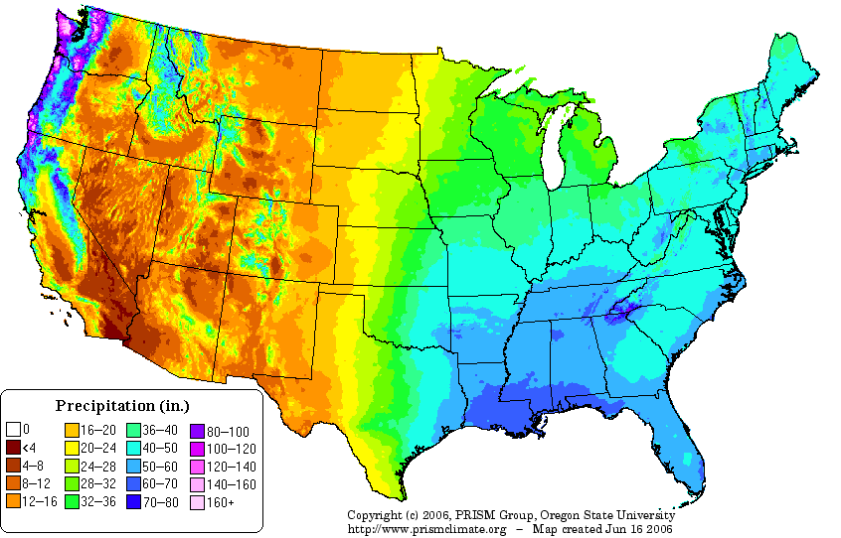

Figure 2. Drought, Population, and Irrigation in Georgia, 1900-2010

Figure 3. Proposed Schedule for Statewide Comprehensive Water Management Plan
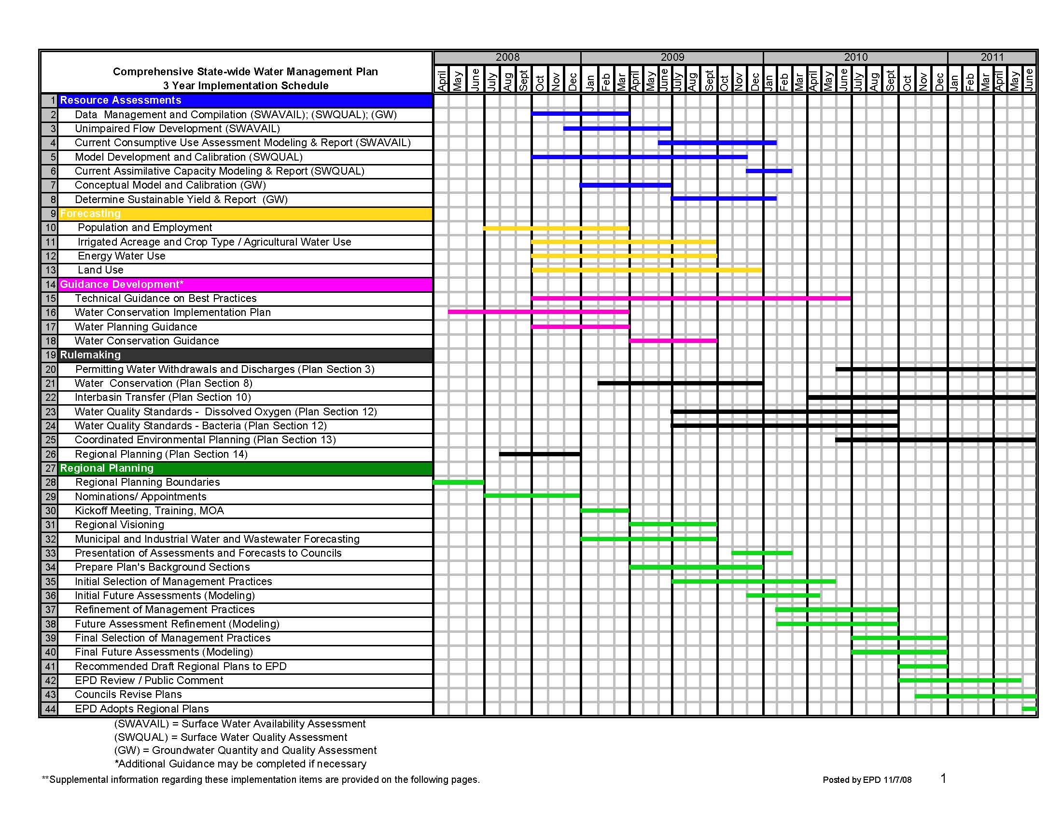

Figure 4. Irrigation Efficiency versus Applied Water Use

References
American Water Works Association. Manual of Water Supply Practices: Principles of Water Rates, Fees, and Charges, fifth edition, 2000.
Baum, M., M. Dukes, G. Miller. “Residential Irrigation Uniformity and Efficiency in Florida.” ASAE Paper Number FL03-100, 2003.
Boggess, W., R. Lacewell, and D. Zilberman. “Economics of Water Use in Agriculture.” in Agricultural and Environmental Resource Economics. G. Carlson, D. Zilberman, and J. Miranowski (eds.), Oxford University Press, New York, NY., 1993.
Boland, J. and D. Whittington. “The Political Economy of Increasing Block Tariffs in Developing Countries.” Paper presented at the World Bank Sponsored Workshop on Political Economy of Water Pricing Implementation, Washington, DC, November 3-5, 1998.
Cavero, J., L. Jimenez, M. Puig, J. Faci, and A. Martinez-Cob. “Maize Growth and Yield under Daytime and Nighttime Solid-Set Sprinkler Irrigation.” Agronomy Journal 100,6(2008): 1573-1579.
Dalhuisen, J.M., R. Florax, H. de Groot, and P. Nijkamp. “Price and Income Elasticities of Residential Water Demand: A Meta-Analysis.” Land Economics 79,2(2003):292-308.
Dziegielewski, Benedykt and Eva Opitz. Municipal and Industrial Water use in the Metropolitan Water District Service Area, Interim Report No. 4. Prepared for the Metropolitan Water District of Southern California, Los Angeles. Planning and Management Consultants, Ltd.,Carbondale, IL, June 1991.

Gaudin, S. “Effect of Price Information on Residential Water Demand.” Applied Economics 38,4(2006):383-393.
Howell, T. “Irrigation Efficiency.” Encyclopedia of Water Science, Marcel Dekker, Inc., New York, NY.
Kanno, Y. and J. Vokoun. 2010. “Evaluating Effects of Water Withdrawals and Impoundments on Fish Assemblages in Southern New England Streams, USA.” Fisheries Management and Ecology 17,3(2003):272-283.
Kieffer, J. and B. Diezielewski. Analysis of Residential Landscape Irrigation in Southern California. Research Report prepared for Metropolitan Water District of Southern California, Los Angeles, CA, December 1991.
Latif, M. and F. Ahmad. “Operational Analysis of Water Applications of a Sprinkler Irrigation System Installed in a Golf Course: Case Study.” Journal of Irrigation and Drainage Engineering 134,4(2008): 446-453.
Martinez-Cob, A., E. Playan, N. Zapata, J. Cavero, E. Medina, and M. Puig. “Contribution of Evapotranspiration Reduction during Solid-Set Sprinkler Irrigation to Application Efficiency.” Journal of Irrigation Drainage and Engineering 134(2008).
Mullen, J.D., Y. Yu, and G. Hoogenboom. “Estimating the Demand for Irrigation Water in a Humid Climate: A Case Study from the Southeastern United States.” Agricultural Water Management 96(2009): 1421-1428.
Planning and Management Consultants, Ltd. IWR-MAIN Water Demand Analysis Software: Technical Overview. Carbondale, Il., 1996.
Playan, E., R. Salvador, J. Faci, N. Zapata, A. Martinez-Cob, and I. Sanchez.. “Day and Night Wind and Drift and Evaporation Loss in Sprinkler Solid-Sets and Moving Laterals.” Agricultural Water Management 76(2005): 139-159.
Rogers, P., R. de Silva, and R. Bhatia. “Water is an Economic Good: How to Use Prices to Promote Equity, Efficiency, and Sustainability.” Water Policy 4(2002): 1-17.
Rosegrant, M., C. Ringler, D. McKinney, X. Cai, A. Keller, G. Donoso. “Integrated Economic-Hydrologic Water Modeling at the Basin Scale: the Maipo River Basin,” Agricultural Economics 24(2000): 33-46.
Yacoubi, S., K. Zayani, N. Zapata, A. Zairi, A. Slatni, R. Salvador, and E. Playan. “Day and Night Time Sprinkler Irrigated Tomato: Irrigation Performance and Crop Yield,” Biosystems Engineering 107,1(2010):25-35.

The other governmental officials included the commissioner of natural resources, the executive director of the State Soil and Water Conservation Commission, the commissioner of community affairs, the commissioner of human resources, the commissioner of agriculture, the director of the Georgia Forestry Commission, and the executive director of the Georgia Environmental Facilities Authority.
The Metropolitan North Georgia Water Planning District, where the city of Atlanta is located, already had a functioning water planning apparatus in place. As such, that district was permitted to continue with their planning activities without additional burdens placed by the state.
Palmer Drought Severity Index interpretation: -1.0 to -1.99 – mild drought; -2.0 to -2.99 – moderate drought; -3.0 to -3.99 – severe drought; -4.0 or less – extreme drought; positive values similarly represent wet conditions.

